**Copy by value a composite data type.**

What changes do we make to our code, so that changes in one array doesn’t affect second array.

We can use the concept of **SPREAD OPERATOR ( … )** to overcome this.  
To have a better understanding, let’s look at below example.

https://miro.medium.com/max/60/1*UxJDJvAB0FWAdLX_HSYwDA.png?q=20

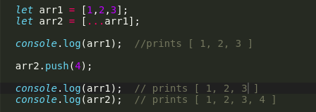

*So,***arr2***makes a copy of its own in the form of***[…arr1]***.  
What***[…arr1]** *does here is, it takes in an array***arr1***and expands it into individual elements, and again it takes the form of array and gets assigned to***arr2.**

*So, the***arr1** *doesn’t get altered even after we make changes to array***arr2***, after the usage of spread operator.*